Sample php exam question.

We are going to simulate “times tables”.

Create a form that takes in 3 numbers.

The start number tells us where to start counting from

The Finish number tells us when to stop

The Add by tells us what increments we ae to go up in

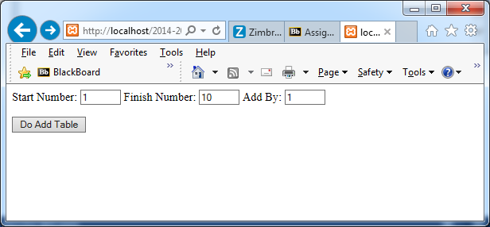

When you click the button a table is generated. As you can see from the example I said start counting at 1, keep going until you get to 10 and add 1 every time.

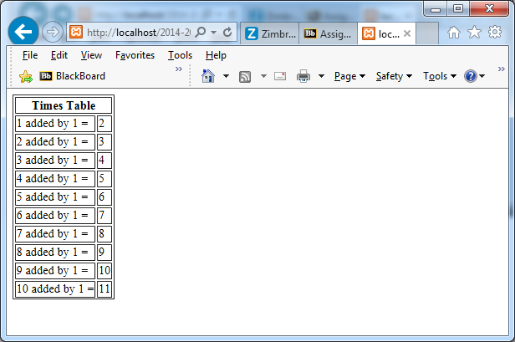

When you take in the numbers make sure that they are integers.

Your CA will consist of 2 questions, do both and will include everything up to Post backs (will not include this hand-out).

I will do a tutorial next week in your first class. Please come with questions, no new material will be covered during this class.

Mail me if you have any problems.